PUBLISH DATA TO THE IBM CLOUD

|  |  |
| --- | --- |
| Team ID | PNT2022TMID18163 |
| Project Name | Project – IOT Based Industry Specific Intelligent Fire Management System. |

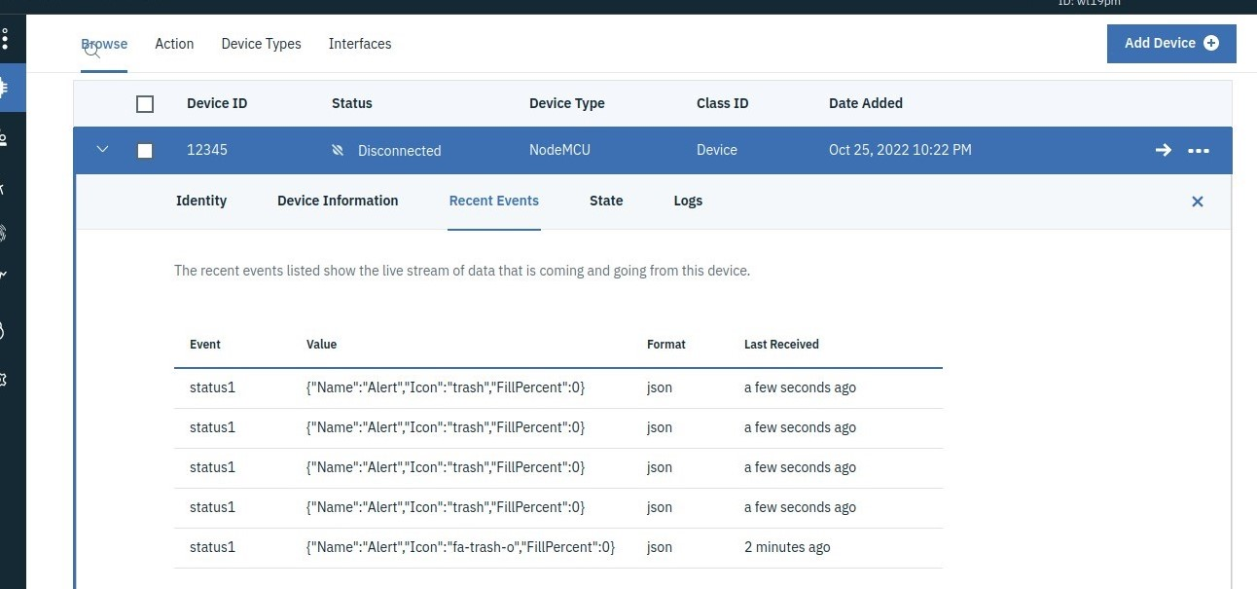

virtualized objects are published to this catalog automatically. The **Publish tocatalog**

option is disabled when you review your cart and virtualize tables.

* On the service menu, click **Virtualization** > **Virtualized data**.
* Select the virtual objects that you want to publish and click **Publishto catalog**.

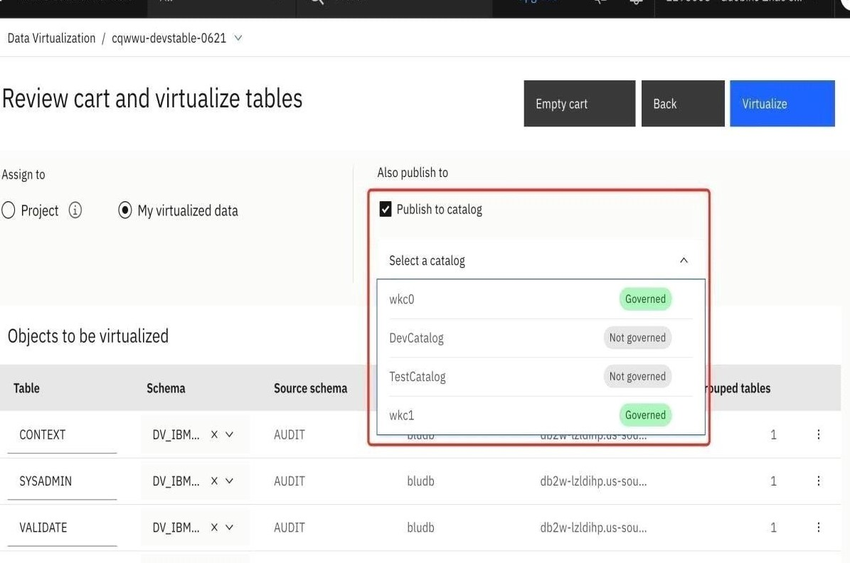

* Continue with the virtualization process